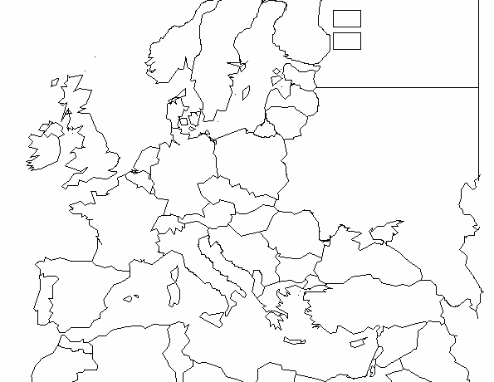
Europe and North Africa
Baltic Sea
ATLANTIC OCEAN
Refer to maps on p. 744, 778 and A16
MIDDLE EAST
Black Sea
Mediterranean
Sea

Countries
Label (and shade)

Germany (Axis = Orange)
Italy (Axis = Orange)
France (Allies = Blue)
Great Britain (Allies = Blue)
Soviet Union (Allies = Blue)

North Africa
Balkans
Austria
Czechoslovakia
Poland

Turning Point Battles
# and show path with arrows – highlight Yellow (read text for description if necessary)

1. Battle of Britain (p. 746-747)
2. Battle of Stalingrad (p. 777)
3. Operation Torch (p. 778-779)
4. D-Day Invasion of Normandy (p. 780-781)
5. Battle of the Bulge (p. 782)

Post-War Hotspots

Iron Curtain (draw line in Red, p. 811)
Palestine/Israel (star in Red, p. 831)

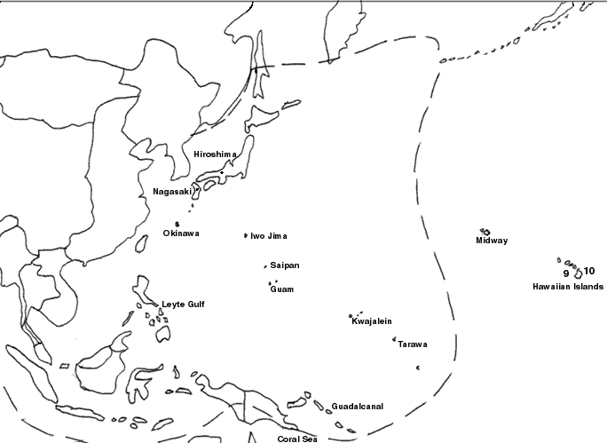
The Pacific

Bering Sea
PACIFIC OCEAN

Refer to maps on p. 762, 786 and A17
INDIAN OCEAN
S. China Sea

Furthest extent of Japanese conquest

Countries
Label (and shade)

Japan (Axis = Orange)
Soviet Union (Allies = Blue)
U.S. Philippines, Hawaii and Alaska
(Allies = Blue)

Manchuria
China
Indochina
Australia (mostly off map)

Turning Point Battles
# and show path with arrows – highlight Yellow (read text for description if necessary)

1. Pearl Harbor (p. 761-762)
2. Battle of Midway (p. 785)
3. Battle of Coral Sea (p. 785)
4. Leyte Gulf (p. 787)
5. Iwo Jima (p. 789)
6. Hiroshima and Nagasaki (p. 790)

Post-War Hotspots

Korea (draw line in Red, p. 819)
Vietnam (star in Red, p. 936-939)

