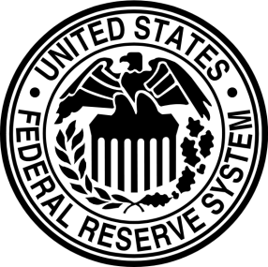
Monetary Policy
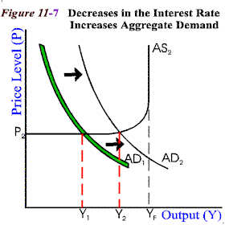
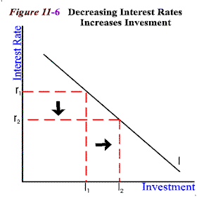
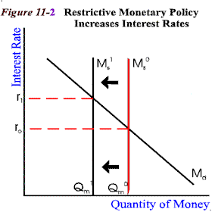

An increase in investment due to lower interest rates also leads to higher aggregate (macro-market) demand because borrowers have more money to spend. The increase in aggregate demand increases output but may also lead to inflation. In time, the Fed may have to raise interest rates again. The purpose of monetary policy is to try to reach equilibrium in the cycle.
Over time, tight money policy causes the economy to contract overall. If the economy enters a recession, the Fed will lower interest rates to encourage spending and investment. With lower interest rates, it is less expensive to borrow money so more people and business take out loans. There will be less money in the banks and more money back in circulation.
When there is high inflation of prices due to an expanding money supply, the Fed may raise interest rates to cause the money supply to contract. Higher interest rates means the cost of borrowing money rises. People and businesses cut back on their loans, so more money is kept in the bank and less money is spent in the economy. With less money in circulation, inflation is slowed.

- What is the purpose of monetary policy?
- How does the Fed encourage economic expansion during a recession?
- What does the Fed do when inflation has become a problem?

- How did the Great Depression significantly change the banking system in America?
- One of the causes of our current economic recessions was poor regulation and management of financial institutions. What were some of the mistakes made?

