Native American DBQ: Documents

Document A
From “Chief Seattle’s Treaty Oration 1854”, As reported in the Seattle Sunday Star on Oct. 29, 1887, in a column by Dr. Henry A. Smith
The white chief says that Big Chief at Washington sends us greetings of friendship and goodwill. This is kind of him for we know he has little need of our friendship in return. His people are many. They are like the grass that covers vast prairies. My people are few. They resemble the scattering trees of a storm-swept plain. The great, and I presume -- good, White Chief sends us word that he wishes to buy our land but is willing to allow us enough to live comfortably. This indeed appears just, even generous, for the Red Man no longer has rights that he need respect, and the offer may be wise, also, as we are no longer in need of an extensive country…

Day and night cannot dwell together. The Red Man has ever fled the approach of the White Man, as the morning mist flees before the morning sun. However, your proposition seems fair and I think that my people will accept it and will retire to the reservation you offer them. Then we will dwell apart in peace, for the words of the Great White Chief seem to be the words of nature speaking to my people out of dense darkness.

It matters little where we pass the remnant of our days. They will not be many. The Indian's night promises to be dark. Not a single star of hope hovers above his horizon. Sad-voiced winds moan in the distance. Grim fate seems to be on the Red Man's trail, and wherever he will hear the approaching footsteps of his fell destroyer and prepare stolidly to meet his doom, as does the wounded doe that hears the approaching footsteps of the hunter.

A few more moons, a few more winters, and not one of the descendants of the mighty hosts that once moved over this broad land or lived in happy homes, protected by the Great Spirit, will remain to mourn over the graves of a people once more powerful and hopeful than yours. But why should I mourn at the untimely fate of my people? Tribe follows tribe, and nation follows nation, like the waves of the sea. It is the order of nature, and regret is useless. Your time of decay may be distant, but it will surely come, for even the White Man whose God walked and talked with him as friend to friend, cannot be exempt from the common destiny. We may be brothers after all. We will see.

Document B
Promotional materials from the Wild West Show (c. 1905). The historical event took place in 1876.
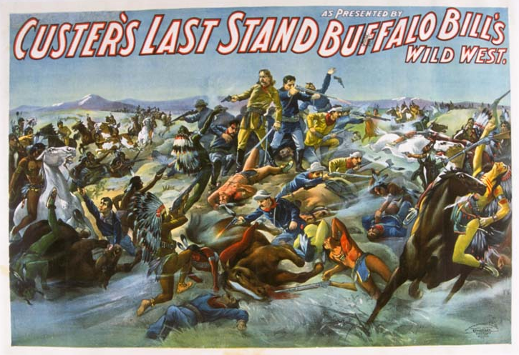
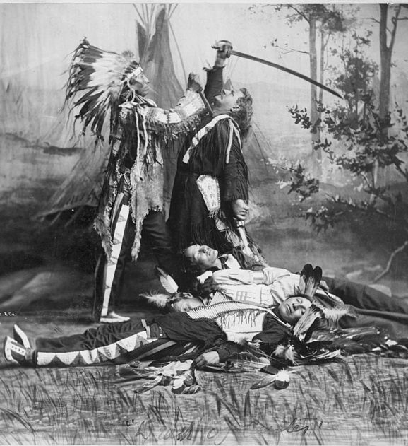

Death of Custer

Custer's Last Stand

Document C
From A Century of Dishonor (1881) by Helen Hunt Jackson

…A band of some three hundred of these Northern Cheyennes took the desperate step of running off and attempting to make their way back to Dakota. They were pursued, fought desperately, but were finally overpowered, and surrendered. They surrendered, however, only on the condition that they should be taken to Dakota. They were unanimous in declaring that they would rather die than go back to the Indian Territory. This was nothing more, in fact, than saying that they would rather die by bullets than of chills and fever and starvation.

These Indians were taken to Fort Robinson, Nebraska. Here they were confined as prisoners of war, and held subject to the orders of the Department of the Interior…Orders came – explicit, repeated, finally stern – insisting on the return of these Indians to their agency. The commanding officer at Fort Robinson…could not take three hundred Indians by sheer brute force and carry them hundreds of miles, especially when they were so desperate that they had broken up the iron stoves in their quarters, and wrought and twisted them into weapons with which to resist. He thought perhaps he could starve them into submission. He stopped the issue of food; he also stopped the issue of fuel to them. It was midwinter, the mercury froze in that month at Fort Robinson. At the end of two days he asked the Indians to let their women and children come out that he might feed them. Not a woman would come out. On the night of the fourth day – or, according to some accounts, the sixth – these starving, freezing Indians broke prison, overpowered the guards, and fled, carrying their women and children with them. They held the pursuing troops at bay for several days; finally made a last stand in a deep ravine, and were shot down – men, women, and children together…

Document D
Three Lakota Boys, Carlisle, c. 1900

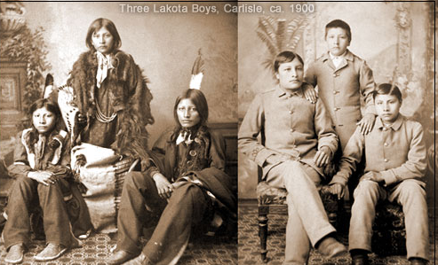

Document E
From Carl Schurz on The Indian Dilemma (1881)

That the history of our Indian relations presents, in great part, a record of broken treaties, of unjust wars, and of cruel spoliation is a fact too well known to require proof or to suffer denial. But is only just to the government of the United States to say that its treaties with Indian tribes were, as a rule, made in good faith…
…most of the Indian wars grew, not from any desire of the government to disturb the Indians in the territorial possessions guaranteed to them but from the restless and unscrupulous greed of frontiersmen who pushed their settlements and ventures into the Indian country, provoked conflicts with the Indians, and then called for the protection of the government against the resisting and retaliating Indians, thus involving it in the hostilities which they themselves had begun. It is true that in some instances Indian wars were precipitated by acts of rashness and violence on the part of the military men without orders from the government…
…To be sure, as to Indian civilization, we must not expect too rapid progress or the attainment of too lofty a standard. We can certainly not transform them at once into great statesmen, or philosophers, or manufacturers, or merchants; but we can make them small farmers and herders…
The Indian, in order to be civilized, must not only learn how to read and write but how to live…
…In order to learn to live like the white man, he should see and observe how the white man lives in his own surroundings, what he is doing, and what he is doing it for…

Document F
From a battlefield report from Wounded Knee, published in The Seattle Post-Intelligencer (Seattle, Washington Territory) on December 30, 1890.

