1A. Herbert Hoover’s Campaign Speech (1928)
Name ______________________ Pd ___ Group ___
STATION 1: PRESIDENTIAL SPEECHES
When the war closed, the most vital of issues both in our own country and around the world was whether government should continue their wartime ownership and operation of many instrumentalities of production and distribution. We were challenged with a... choice between the American system of rugged individualism and a European philosophy of diametrically opposed doctrines—doctrines of paternalism and state socialism…The Republican Party from the beginning resolutely turned its face away from these ideas and war practices... it restored the government to a position as an umpire instead of a player in the economic game....
I do not wish to be misunderstood.... I am defining general policy.... I have already stated that where the government is engaged in public works for purposes of flood control, of navigation, of irrigation, of scientific research or national defense... it will at times necessarily produce power or commodities as a by-product…Nor do I wish to be misinterpreted as believing that the United States is a free-for-all and devil-take-the-hindmost. The very essence of equality of opportunity and of American individualism is that there shall be no domination by any group or [monopoly] in this republic.... It is no system of laissez faire....
By adherence to the principles of decentralized self-government, ordered liberty, equal opportunity, and freedom to the individual, our American experiment in human welfare has yielded a degree of well-being unparalleled in the world. It has come nearer to the abolition of poverty, to the abolition of fear of want, than humanity has ever reached before....

1B. Franklin D. Roosevelt’s First Inaugural Address (1933)
Our greatest primary task is to put people to work…It can be accomplished in part by direct recruiting by the Government itself, treating the task as we would treat the emergency of a war, but at the same time, through this employment, accomplishing greatly needed projects to stimulate and reorganize the use of our natural resources….
The task can be helped by definite efforts to raise the values of agricultural products and with this the power to purchase the output of our cities. It can be helped by preventing realistically the tragedy of the growing loss through foreclosure of our small homes and our farms…It can be helped by the unifying of relief activities which today are often scattered, uneconomical, and unequal….
Finally, in our progress toward a resumption of work we require two safeguards against a return of the evils of the old order; there must be a strict supervision of all banking and credits and investments; there must be an end to speculation with other people's money, and there must be provision for an adequate but sound currency….
Action in this image and to this end is feasible under the form of government which we have inherited from our ancestors. Our Constitution is so simple and practical that it is possible always to meet extraordinary needs by changes in emphasis and arrangement without loss of essential form…We do not distrust the future of essential democracy. The people of the United States have not failed. In their need they have registered a mandate that they want direct, vigorous action….
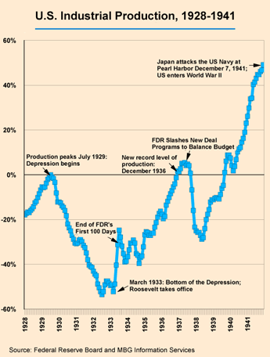
Name ______________________ Pd ___ Group ___
STATION 2: FACTS AND FIGURES
2A.
U.S. Timeline: 1917-1944
1917 U.S. enters World War I
1918 World War I ends
Soviet Union established
1919 Prohibition begins
1920 19th Amendment
1923 Coolidge elected
German economic crisis
1925 Scopes Trial
1927 Ford introduces Model A
1928 Herbert Hoover elected
1929 Stock Market crashes
1930 Widespread bank failures begin
1932 FDR elected
Unemployment at all-time high
1933 New Deal begins
Prohibition repealed
1935 Social Security Act passed
1937 NLRB v. Jones and Laughlin
1939 Allies declare war on Axis
1941 Pearl Harbor, U.S. joins Allies
1944 FDR elected for 4th time
Source: The Americans

2B.

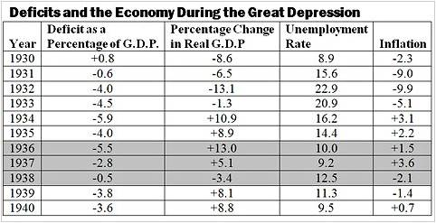
2C.

Source: New York Times

Name ______________________ Pd ___ Group ___
STATION 3: TAKING SIDES DEBATE POINTS

FROM Taking Sides: Clashing Views on Controversial Issues in American History, Vol, 2
Was the New Deal an Effective Answer to the Great Depression?
3A. From “The Achievement of the New Deal”  by Wiliam E. Leuchtenburg |  | 3B. From Pride, Prejudice, and Politics:  Roosevelt Versus Recovery by Gary Dean Best
The Roosevelt Administration, it has been asserted, failed to achieve more than it did not…because Roosevelt deliberately sought to save “large-scale corporate capitalism”….There were experiments of the 1930s which miscarried, opportunities that were fumbled, groups who were neglected, and power that was arrogantly used. Over the whole performance lies the dark cloud of the persistence of hard times…But I am not persuaded that the New Deal experience was negligible. Indeed, it is hard to think of another period in the whole history of the republic that was so fruitful or of a crisis that was met with as much imagination. | OVERALL EVALUATION | Roosevelt’s achievements in alleviating the hardship of the depression are deservedly well known, his responsibility for prolonging the hardship is not. His role in providing long-overdue social and economic legislation is in every high school American history textbook, but the costs for the United States of his eight-year-long war against business recovery are mentioned in none…We can only speculate concerning the possible alterations of events from 1937 onward had the United States faced the world with the economic and military potential it might have displayed had wiser economic policies prevailed…
Under the umbrella of Section 7(a) of the National Industrial Recovery Act of 1933 and of the far-reaching Wagner Act of 1935, union organizers gained millions of recruits in such open-shop strongholds as steel, automobiles, and textiles. Employees won wage raises, reduction in hours, greater job security, freedom from the tyranny of company guards, and protection against arbitrary punishment. | LABOR | The pay raises, especially, were passed on in the form of higher prices, as were the social security taxes that were imposed on businesses beginning with 1937. Labor disturbances, encouraged by the Wagner Labor Act and the Roosevelt alliance with John L. Lewis’ Congress of Industrial Organization in the 1936 campaign, added further to the wage-price spiral that threatened as 1937 unfolded.
The President became, in Sidney Hyman’s words, “the chief economic engineer,” to whom Congress naturally turned for the setting of economic policy…Before 1937 the Supreme Court stood as a formidable barrier to social reform. Since 1937 not one piece of significant social legislation has been invalidated, and the Court has shifted its docket instead to civil rights and civil liberties… | SEPARATION OF POWER | The grant of such unprecedented peacetime authority to an American president aroused concern, but these after all were only “emergency” powers, to be given up once recovery was on its way. Or were they?...The weight of the negative aspects would, moreover, have been much heavier except for the existence of a free and alert press, and for the actions of the Supreme Court and Congress in nullifying, modifying, and rejecting…
During the ten years between 1929 and 1939, one scholar has written, “more progress was made in public welfare and relief than in the three hundred years after this country was first settled.” A series of alphabet agencies – the FERA, the CWA, the WPA – provided government work for the jobless…In New York City alone the WPA employed more people than the entire War Department…The New Deal showed unusual sensitivity towards jobless white-collar workers… the progression of enactments starting with the first AAA of 1933…began the process of granting large-scale subsidies to growers… | DEFICIT SPENDING | Conventional wisdom has it that the massive government spending of World War II finally brought a Keynesian recovery from the depression. Of more significance, in comparison of the prewar and wartime economic policies of the Roosevelt administration, is the fact that the war against business that characterized the former was abandoned in the latter… Antibusiness advisers were replaced by businessmen, pro-labor policies became pro-business policies…even the increased spending of the war years “trickled down” rather than “bubbling up.”
Name ______________________ Pd ___ Group ___
STATION 4: POLITICAL CARTOONS AND SONGS
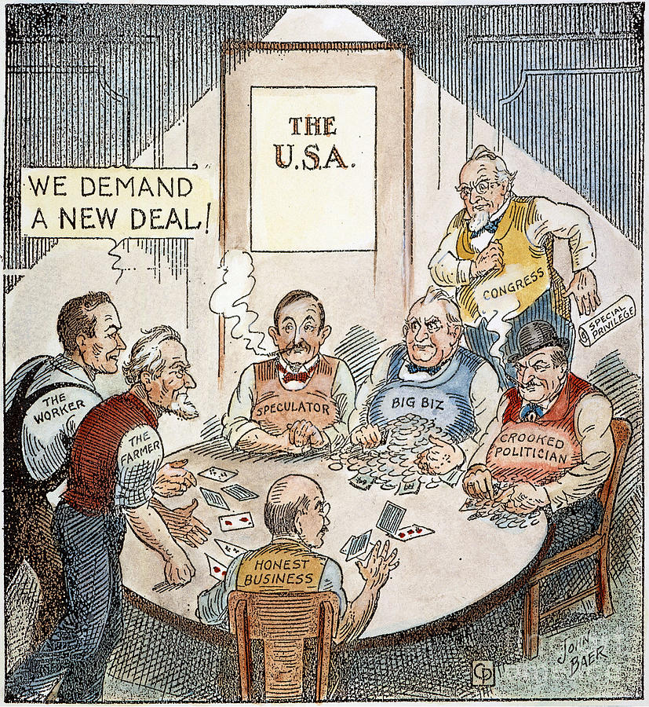
4A.
4B.
“Brother, Can You Spare a Dime?”
E.Y. "Yip" Harburg and Jay Gorney, 1932
They used to tell me I was building a dream
And so I followed the mob
When there was earth to plow or guns to bear
I was always there, right on the job
They used to tell me I was building a dream
With peace and glory ahead
Why should I be standing in line
Just waiting for bread?
Once I built a railroad, I made it run
Made it race against time
Once I built a railroad, now it's done
Brother, can you spare a dime?
Once I built a tower up to the sun
Brick and rivet and lime
Once I built a tower, now it's done
Brother, can you spare a dime?

Read more: Bing Crosby - Brother Can You Spare A Dime Lyrics | MetroLyrics

John Baer, 1932

4C.
4D.
“This Land,” Woody Guthrie
Lost verses from the original 1940 lyrics

Was a high wall there that tried to stop me
A sign was painted said: Private Property,
But on the back side it didn't say nothing —
This land was made for you and me.

When the sun come shining,
then I was strolling
In wheat fields waving and
dust clouds rolling;
The voice was chanting
as the fog was lifting:
This land was made for you and me.

One bright sunny morning
in the shadow of the steeple
By the Relief Office I saw my people —
As they stood hungry,
I stood there wondering if
This land was made for you and me.

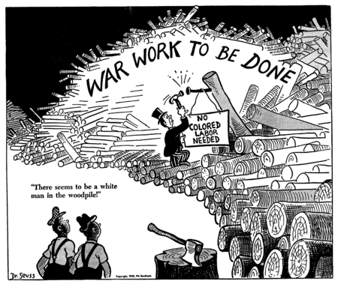

Dr. Seuss, 1942

