How Demand Works
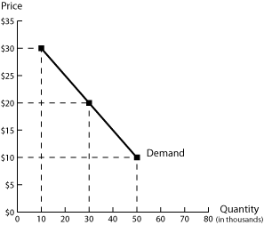
A. Law of Demand (Micro)
“Consumers will buy more of a product at a low price
than at a high price…” Why?
“…if everything else remains the same.” What does
this mean?

B. Market Demand (Macro)
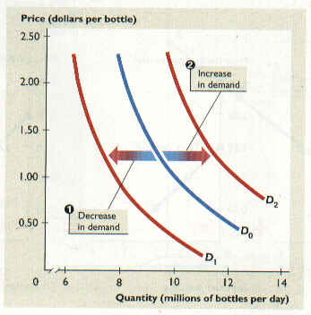
How could these factors cause a change in the overall market demand for a product?
- Inflation
- Average Income
- Population
- Complements
- Substitutes
- Tastes and fads
- Expectations
C. Elasticity of Demand
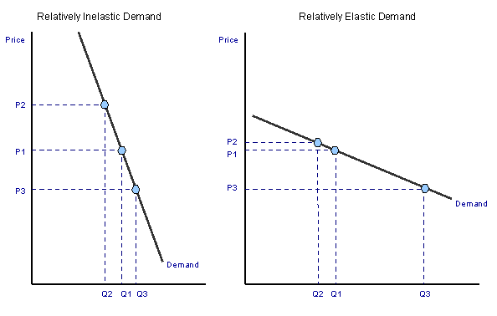
Refers to how responsive consumers
are to a change in price
Why do these factors help determine the elasticity of demand for a product?
- Substitutes
- Percentage of Income
- Urgency
- Necessity
How Supply Works
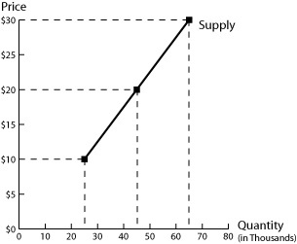
A. Law of Supply (Micro)
“Producers will produce more of a product at a high price
than at a low price…” Why?
“…if everything else remains the same.” What does
this mean?

B. Market Supply (Macro)
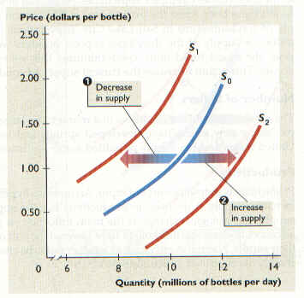
How could these factors cause a change in the overall market supply of a product?
- Available resources
- Costs of production
- Government regulation
- Opinions and expectations
- Taxes
- Technology
- Subsidies
- Number of Suppliers
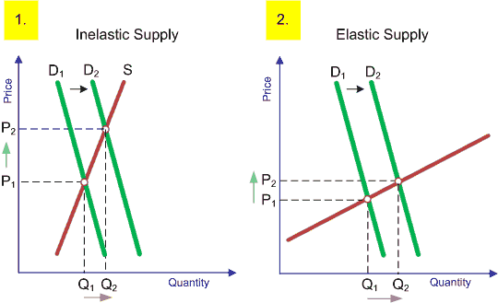
C. Elasticity of Supply
Refers to how responsive producers
are to a change in demand
Why do these factors help determine the elasticity of supply for a product?
- Availablility of resources
- Production capabilities
How Supply and Demand Work Together
- The “Invisible Hand”
What did Adam Smith mean when he said the interaction of supply and demand acted like an “invisible hand” in the free market?
What kind of economic policies would he support? Oppose?
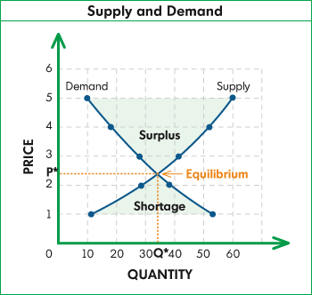
- Equilibrium Price
What could cause a surplus?
What happens to price if there is a surplus?

What could cause a shortage?
What happens to price if there is a shortage?

- Price Controls
What would Adam Smith think about the use of price ceilings and price floors?
How are these similar to tariffs and quotas?
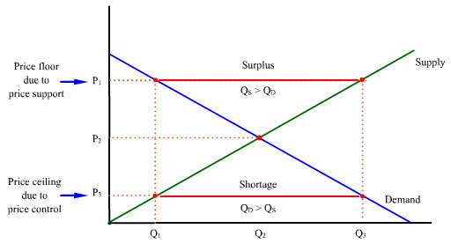

Example of a price floor:

Example of a price ceiling:

