Town Council Agenda
The major issues for this election are:
1. Schools performing below average on state tests.
2. Receiving a grant from the federal government to build a dam.
3. The downsizing of a major employer, Mo’Town furniture factory.
Republican Proposals
1. Schools perform below average
a. Students will be allowed to choose what schools they prefer to go to through the school choice program so they have an opportunity for a good school.
b. If the student does not like the school he is accepted into, vouchers will be provided to allow low income students to attend private schools.
2. Federal funding for dam
a. We want the funding for the dam because it will allow contractors to compete for the responsibility of building the dam. Contractors will want to build the dam because there is a tax break incentive for that company.
3. Mo’Town furniture factory downsized
a. We want to get Mo'Town furniture factory back on its feet. But, it should be done under their own power because we believe in a free market economy with little government intervention.
Democratic Proposals
1. Schools perform below average
a. In order to improve school performance, the Democratic Party proposes an increase in funding for core classes.
2. Federal funding for dam
a. The Democratic Party requests funding for the construction of the Mo’town dam in order to eliminate wasted resources, create energy, and stop flooding.
b. The construction and operation would create more jobs.
3. Mo’town furniture factor downsized
a. By rebooting the furniture factory, its first major task would be to provide for the new strip mall the Democrat Party will build. This, in turn, will boost the economy by providing steady jobs for the citizens of Mo’town.

- 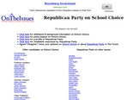
Republican Party on School Choice
ontheissues.org
- 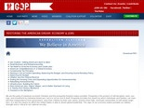
Restoring the American Dream: Economy & Jobs - GOP
gop.com

  - 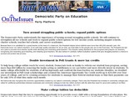
Democratic Party on Education
ontheissues.org
Hydroelectric Power (Dams)
mbgnet.net
- Show fewer attachments

