Is “The Wizard of Oz” a Populist Allegory?
al⋅le⋅go⋅ry (n) a story, poem, or picture that can be interpreted to reveal a hidden meaning, typically a moral or political one.
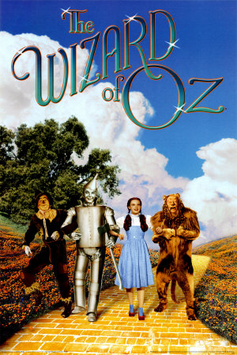
Background info to consider:
- The movie is based on a book called The Wonderful Wizard of Oz, written in 1900 by L. Frank Baum. His description of Kansas in the book was based on his experience living in South Dakota.
- Baum was not affiliated with the People’s Party or the populist movement, though he was outspoken about women’s suffrage and wrote some controversial articles about Native Americans. (According to Wikipedia, he was a Republican who supported McKinley but sang in a barbershop quartet with a major People’s Party leader. The Real Wizard of Oz e-book claims that he showed some support of bimetallism because he was forced to leave South Dakota due to the economic depression of the 1890s.)
- The theory of the story being an allegory for populism was proposed by a
high school teacher in the 1960s trying to make class more interesting
for his students.
Historical facts to review:
- Deflation plus Railroad charges for shipping and storage cause farmers in the West to get buried in debt, so farmers begin to organize into groups like the Farmers’ Alliance and The Grange.
- Railroad companies also faced criticism due to dangerous and poor conditions for workers and corruption scandals
like Crédit Mobilier.
- The Grange finally convinced some states to pass laws regulating railroad activity, and Munn v. Illinois and the Interstate Commerce Act made federal regulation legal.
- The Populist movement grew based on a platform of more political and economic power for the common people through reforms like direct election of senators, graduated income tax, and bimetallism. It also included some reforms for industrial workers such as an eight-hour workday.
- During the Panic of 1893, Populist and “silverite” William Jennings Bryan made the famous “Cross of Gold” speech and earned the presidential nomination of the People’s Party and the Democratic Party. He lost to Republican and “gold bug” William McKinley, who was supported by banks and big business in the East.
- Though the Populist movement ended with the election, it sent the message that poor and less powerful groups could organize and make a political impact. Many of its proposed reforms were adopted later by the Democratic Party.
Coincidence?
- In the book, Dorothy’s shoes are silver. They used ruby ones in the movie so they would show up against the yellow brick road using the new Technicolor process.
- Also in the book, the Wizard is from Omaha. The People’s Party platform is commonly referred to as the Omaha platform because it was written there in 1892. In the movie, the Wizard says he is from Kansas but his hot air balloon says Omaha.
- Oz is the abbreviation for ounce, which is the standard measure of unit for gold. Greenbacks (not backed by silver or gold) printed during the Civil War contributed to the post-war deflation problem.

Quotes from the book:
- "She [the Witch of the West] looked down at Dorothy's feet, and seeing the Silver Shoes, began to tremble with fear, for she knew what a powerful charm belonged to them. At first the Witch was tempted to run away from Dorothy; but she happened to look into the child's eyes and saw how simple the soul behind them was, and that the little girl did not know of the wonderful power the Silver Shoes gave her. So the Wicked Witch laughed to herself, and thought, 'I can still make her my slave, for she does not know how to use her power.' Then she said to Dorothy, harshly and severely, 'Come with me; and see that you mind everything that I tell you, for if you do not I will make an end to you, as I did of the Tin Woodman and the Scarecrow.'"
- "After a few hours the road began to be rough, and the walking grew so difficult that the Scarecrow often stumbled over the yellow brick, which were here very uneven. Sometimes, indeed, they were broken or missing altogether, leaving holes that Toto jumped across and Dorothy walked around. As for the Scarecrow, having no brains he walked straight ahead, and so stepped into the holes and fell full length on the hard bricks."
- “I [Scarecrow] cannot understand why you should wish to leave this beautiful country and go back to the dry, gray place you call Kansas." "That is because you have no brains," answered the girl. "No matter how dreary and gray our homes are, we people of flesh and blood would rather live there than in any other country, be it ever so beautiful. There is no place like home."
- “Dorothy said nothing. Oz had not kept the promise he made her, but he had done his best. So she forgave him. As he said, he was a good man, even if he was a bad Wizard.”

Story Elements | Possible Populist Symbolism
Yellow Brick Road to Oz/Emerald City
Dorothy
Munchkins
Scarecrow
Tin Woodman
Cowardly Lion
Wizard of Oz
Wicked Witches of the East and West
Good Witches of the North and South
Tornado
Toto
Flying Monkeys
Poppy fields
Water (spoiler alert: it kills WW-West)

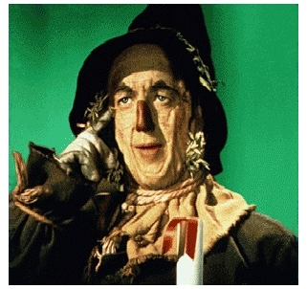
Writing Prompt

Based on the evidence, do you believe that “The Wizard of Oz” is a Populist allegory? Support your opinion with specific historical facts and details from the book/movie. You are welcome to do your own additional research and/or watch the full-length movie, but it is not required. There is no right or wrong answer – it is all just speculation, and the point of the assignment is to think about Populism and have fun using your BRAIN!

