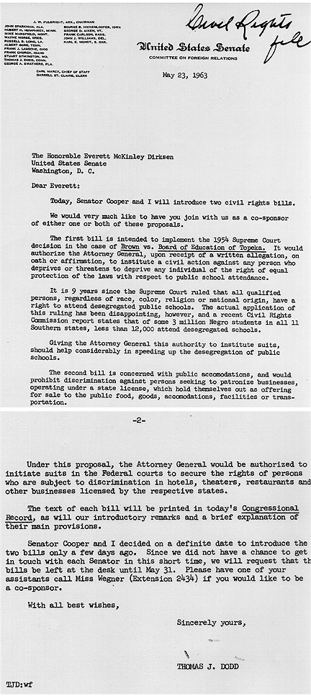
Narrative: Civil Rights Act of 1964
(www.congresslink.org)

Committee Consideration in House and Senate
Although either house of Congress could have taken the lead in considering civil rights legislation in 1963 and 1964, the Senate preferred to delay action until the House considered the legislative package proposed by the President. Senate leaders prevented the Judiciary Committee and the Commerce Committee from formally reporting any of the several civil rights proposals they considered in 1963, including S.1731 and S.1732 which contained the Justice Department's proposals. (For a legislative history, click here.) If a bill had been reported, it could have been called up for consideration and debate on the Senate floor. The leadership did not want to risk a filibuster they knew would result because it would delay other Senate business. It was more difficult to get a bill through Senate committee for another reason: both the Judiciary and the Commerce committees were chaired by southern conservative senators.
As a result of this strategy on the part of the Senate leadership, the initial focus of activity on what was to become the Civil Rights Act of 1964 took place in the House of Representatives.
Senate Republicans meet in conference to plan legislative strategies during May 1964 [64/5/0-3]
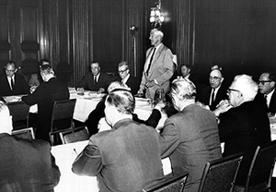
House Debate and Passage
The House of Representatives debated the bill for nine days and rejected nearly one hundred amendments designed to weaken the bill before passing H.R .7152 on February 10, 1964. Of the 420 members who voted, 290 supported the civil rights bill and 130 opposed it. Republicans favored the bill 138 to 34; Democrats supported it 152-96. It is interesting to note that Democrats from northern states voted overwhelmingly for the bill, 141 to 4, while Democrats from southern states voted overwhelmingly against the bill, 92 to 11. A bipartisan coalition of Republicans and northern Democrats was the key to the bill's success. This same arrangement would prove crucial later to the Senate's approval of the bill.
House action on the bill had been nearly exhaustive. In total, the House held 70 days of public hearings, listened to 275 witnesses, and published 5,792 pages of testimony. It was now up to the Senate to decide the bill's ultimate fate: Would H. R. 7152 become the most important civil rights law of the century or would it die like so many previous attempts?

Senate Floor Debate: Leadership Strategy
When the House-passed bill reached the Senate floor in March 1964, three groups of senators formed: pro-civil rights Democrats, southern Democrats opposed to the bill, and Republicans. Senator Hubert H. Humphrey led the Democrats who supported the bill and worked actively for its passage. As Senate majority whip, Humphrey enjoyed the support of Mike Mansfield, Senate majority leader. Together they were determined to pass the legislation and even arranged grueling twelve-hour daily sessions to wear down the opposition. Humphrey's task was to line up supporters to defend the bill in debate, to persuade reluctant members of his party to vote for passage, to encourage publicity, and to count votes. The Senator from Minnesota labored hard for passage and sought cooperation from many sources, including the Republicans.
Senator Richard Russell, Democrat from Georgia, led the so-called opposition forces. The group was also known as the "southern bloc." It was composed of eighteen southern Democrats and one Republican, John Tower of Texas. Although a hopeless minority, the group exerted much influence because Senate rules virtually guaranteed unlimited debate unless it was ended by cloture. The "southern bloc" relied on the filibuster to postpone the legislation as long as possible, hoping that support for civil rights legislation throughout the country would falter. The Democratic leadership and Humphrey could not control the southern wing of the party.
Russell's forces disliked civil rights legislation for several reasons. Many feared that their southern constituents would vote them out of office if, as senators, they voted for equal rights for African Americans. The "southern bloc" held up consideration of the bill from March into June hoping that presidential candidate George Wallace, a segregationist from Alabama, would do well in the early presidential primaries. If Wallace seemed popular, Russell would argue that the nation as a whole did not support federal civil rights legislation and that the Senate should not pass an unwanted bill. Southern senators could not compromise. Only by forcing cloture could they demonstrate to their constituents that they had fought to the end against hopeless odds.
Senate Debate, "The Long Hard Furrow"
As the civil rights debate unfolded, it became increasingly clear that the southern bloc objected most strongly to two sections of the bill, the cut-off of federal funds to projects that discriminated against African Americans and the provision for fair employment practices enforcement. Many Republicans, including the "swing" senators, joined the southerners in their concern about the impact of fair employment provisions on business, particularly small businesses. Even in states with no racial problem, the prospect of making employers comply with the law seemed to many Republican to be an unwarranted expansion of federal power. Early in April 1964, Everett Dirksen, who had expressed reservations about the bill, indicated to the press that he might offer amendments to the fair employment practices title. Although President Johnson had made it clear that the administration wanted the Senate to accept the House bill without change, the Republicans met in study groups throughout April in an effort to make the bill more acceptable through modification.
Dirksen first discussed his proposals to modify the bill with the Senate Republican Policy Committee on March 31 and then with all Republican senators. Dirksen knew that to persuade Republicans to support northern Democrats in their effort to end the filibuster, he would have to make the bill itself acceptable to the "swing" senators. He met repeatedly with his Republican colleagues in an attempt to forge a consensus on appropriate changes. The task was not an easy one, and several senators objected to Dirksen's tactics and recommendations. At one point Dirksen explained his goal as ". . . first, to get a bill; second, to get an acceptable bill; third, to get a workable bill; and, finally, to get an equitable bill." Slowly the rough consensus that Dirksen sought began to emerge.
Rather than stressing the moral or racial questions involved, Dirksen focused on a compromise that emphasized state responsibility for civil rights enforcement. The Senate minority leader realized that the "swing" votes would not be persuaded social arguments but by assurances that federal government intervention in local affairs would be kept to a minimum. Dirksen eventually proposed ten amendments for his colleagues' consideration that assured the states primary jurisdiction over complaints about discrimination during a transition period before the federal government entered the picture. Dirksen's modified bill appeared to satisfy enough Republicans to guarantee that the prolonged filibuster would be ended when a vote could be scheduled.
Meanwhile, the filibuster continued throughout the entire month of April into May. Two- hour speeches were common, but occasionally a senator would speak without interruption for eight hours. Senator Dirksen remembered that one of his colleagues brought a 1,500 page speech to deliver on the Senate floor. The filibuster virtually immobilized the Senate in all its other activities.
The Johnson administration realized that it would have to fashion some kind of compromise with the Republicans and Everett Dirksen in order to persuade the "swing" votes under Dirksen's influence to favor cloture.
Cloture
On June 10,1964, after an impassioned plea by Dirksen on behalf of the compromise bill, the Senate voted 71 to 29 to close off the civil rights filibuster. Every member of the Senate was present for the vote, including Senator Engle of California who had suffered a stroke and could not speak but pointed to his eye as a sign of his "aye" vote. The margin was four votes larger than the 67 required. It ended 57 days of debate, the longest debate since the cloture rule had been adopted in 1917. Forty four Democrats and 27 Republicans supported cloture; 23 Democrats and 6 Republicans opposed it.
Supporters of the civil rights bill in the Senate celebrate the cloture vote on June 10, 1964 [64/6/10- 10]
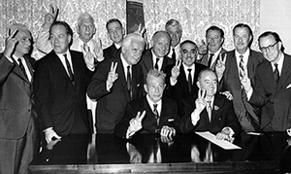
Several factors combined to impel senators to vote for cloture besides the merits of bill. Many simply wished to move on to other Senate business. Some were candidates for reelection in 1964 and wanted to speed up the work so they could return home to campaign. Still others needed to prepare for the up-coming national party conventions. Finally, there were the "swing" Republicans who had listened to Dirksen and had senators voted for cloture because Dirksen had persuaded them: Carl Curtis and Roman Hruska of Nebraska; Karl Mundt of South Dakota; and Jack Miller of Iowa. Without Dirksen's assistance, there is little doubt that the civil rights forces would have been defeated in their attempt to end debate.

President Lyndon B. Johnson's

Radio and Television Remarks Upon Signing the Civil Rights Bill

July 2, 1964

[ Broadcast from the East Room at the White House at 6:45 p.m. ]

My fellow Americans:

I am about to sign into law the Civil Rights Act of 1964. I want to take this occasion to talk to you about what that law means to every American.

One hundred and eighty-eight years ago this week a small band of valiant men began a long struggle for freedom. They pledged their lives, their fortunes, and their sacred honor not only to found a nation, but to forge an ideal of freedom--not only for political independence, but for personal liberty--not only to eliminate foreign rule, but to establish the rule of justice in the affairs of men.

That struggle was a turning point in our history. Today in far corners of distant continents, the ideals of those American patriots still shape the struggles of men who hunger for freedom.

This is a proud triumph. Yet those who founded our country knew that freedom would be secure only if each generation fought to renew and enlarge its meaning. From the minutemen at Concord to the soldiers in Viet-Nam, each generation has been equal to that trust.

Americans of every race and color have died in battle to protect our freedom. Americans of every race and color have worked to build a nation of widening opportunities. Now our generation of Americans has been called on to continue the unending search for justice within our own borders.

We believe that all men are created equal. Yet many are denied equal treatment.

We believe that all men have certain unalienable rights. Yet many Americans do not enjoy those rights.

We believe that all men are entitled to the blessings of liberty. Yet millions are being deprived of those blessings--not because of their own failures, but because of the color of their skin.

The reasons are deeply imbedded in history and tradition and the nature of man. We can understand--without rancor or hatred--how this all happened.

But it cannot continue. Our Constitution, the foundation of our Republic, forbids it. The principles of our freedom forbid it. Morality forbids it. And the law I will sign tonight forbids it.

That law is the product of months of the most careful debate and discussion. It was proposed more than one year ago by our late and beloved President John F. Kennedy. It received the bipartisan support of more than two-thirds of the Members of both the House and the Senate. An overwhelming majority of Republicans as well as Democrats voted for it.

It has received the thoughtful support of tens of thousands of civic and religious leaders in all parts of this Nation. And it is supported by the great majority of the American people.

The purpose of the law is simple.

It does not restrict the freedom of any American, so long as he respects the rights of others.

It does not give special treatment to any citizen.

It does say the only limit to a man's hope for happiness, and for the future of his children, shall be his own ability.

It does say that there are those who are equal before God shall now also be equal in the polling booths, in the classrooms, in the factories, and in hotels, restaurants, movie theaters, and other places that provide service to the public.

I am taking steps to implement the law under my constitutional obligation to "take care that the laws are faithfully executed."

First, I will send to the Senate my nomination of LeRoy Collins to be Director of the Community Relations Service. Governor Collins will bring the experience of a long career of distinguished public service to the task of helping communities solve problems of human relations through reason and commonsense.

Second, I shall appoint an advisory committee of distinguished Americans to assist Governor Collins in his assignment.

Third, I am sending Congress a request for supplemental appropriations to pay for necessary costs of implementing the law, and asking for immediate action.

Fourth, already today in a meeting of my Cabinet this afternoon I directed the agencies of this Government to fully discharge the new responsibilities imposed upon them by the law and to do it without delay, and to keep me personally informed of their progress.

Fifth, I am asking appropriate officials to meet with representative groups to promote greater understanding of the law and to achieve a spirit of compliance.

We must not approach the observance and enforcement of this law in a vengeful spirit. Its purpose is not to punish. Its purpose is not to divide, but to end divisions--divisions which have all lasted too long. Its purpose is national, not regional.

Its purpose is to promote a more abiding commitment to freedom, a more constant pursuit of justice, and a deeper respect for human dignity.

We will achieve these goals because most Americans are law-abiding citizens who want to do what is right.

This is why the Civil Rights Act relies first on voluntary compliance, then on the efforts of local communities and States to secure the rights of citizens. It provides for the national authority to step in only when others cannot or will not do the job.

This Civil Rights Act is a challenge to all of us to go to work in our communities and our States, in our homes and in our hearts, to eliminate the last vestiges of injustice in our beloved country.

So tonight I urge every public official, every religious leader, every business and professional man, every workingman, every housewife--I urge every American--to join in this effort to bring justice and hope to all our people--and to bring peace to our land.

My fellow citizens, we have come now to a time of testing. We must not fail.

Let us close the springs of racial poison. Let us pray for wise and understanding hearts. Let us lay aside irrelevant differences and make our Nation whole. Let us hasten that day when our unmeasured strength and our unbounded spirit will be free to do the great works ordained for this Nation by the just and wise God who is the Father of us all.

Thank you and good night.

NOTE: The Civil Rights Act of 1964 is Public Law 88-352 (78 Stat. 241).

Source: Public Papers of the Presidents of the United States: Lyndon B. Johnson, 1963-64. Volume II, entry 446, pp. 842-844. Washington, D. C.: Government Printing Office, 1965.

Last Updated June 6, 2007

