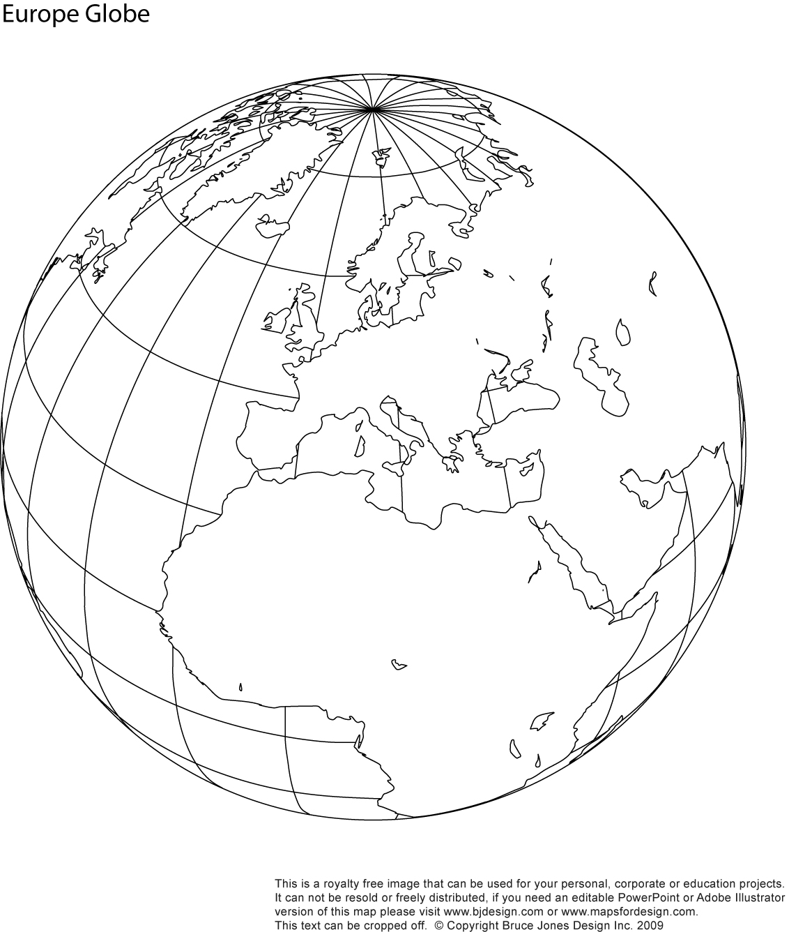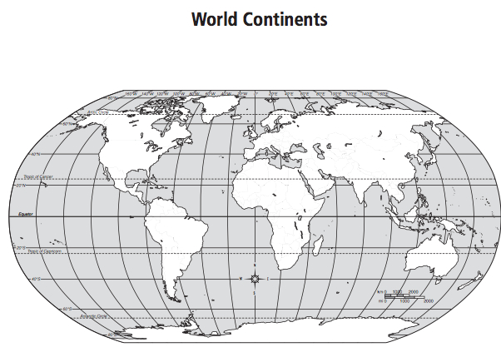

World Map = Before WWI

❑ New States (Hawaii and Alaska)

❑ Protectorates and Territories acquired in Spanish-American and   
Filipino-American War (Cuba, Puerto Rico, Philippines, Guam)

❑ Big Stick Diplomacy (Panama/Columbia, Japan/Russia)

❑ Dollar Diplomacy (Nicaragua)

❑ Missionary Diplomacy (Mexico)

❑ World War I European Allies (Great Britain, France, Serbia, Russia)

❑ WW I Central Powers (Germany, Austria-Hungary, Ottoman Empire)

Inset Map = After WWI

❑ Major changes in Europe that play into WWII (Austria, Czechoslovakia, Yugoslavia, Poland, Soviet Union)

❑ Mandate system of temporary colonization that plays into ongoing conflict   
in the Middle East (Palestine, Syria, Jordan, Iraq, Lebanon)