Unit 1 Gilded Age Vocab – Part A New South and Great West
- Populism: A political movement in the late 1800s, representing working class, or “common people,” based on belief that people should have a greater voice in government and sought to advance the interests of farmers and laborers.
- Debt peonage: Also called debt slavery or debt servitude, a system where a worker is bound in servitude until their debts are paid to his or her employer.
- Massacre: Indiscriminate and brutal slaughter of a group of people, usually unarmed or otherwise defenseless.
- Bimetallism: A monetary system that utilizes both gold and silver as the basis of the national currency. In the late 1800s, the idea was proposed as a way to increase the money supply.
- Exoduster: An African American who migrated from the South to western areas like Kansas after Reconstruction.
- Lynching: A mob of people killing (usually hanging or burning) someone accused of a crime in public without legal authority.
- Homesteader: A settler who moved west to establish a self-sufficient agricultural lifestyle. In 1862 the U.S. government offered 160 acres to any citizen who would move west and cultivate the land as a homestead.
- Muckraker: An investigative journalist who exposed the corrupt side of business and public life in the early 1900s.
- Political machine: An organized group that controls a political party at the state/local level, offering services to voters and businesses in exchange for support.
- Assimilation: A minority group’s adoption (voluntarily or forced) of the beliefs and way of life of the dominant culture.
Unit 1 Gilded Age Vocab – Part A New South and Great West
- Populism: A political movement in the late 1800s, representing working class, or “common people,” based on belief that people should have a greater voice in government and sought to advance the interests of farmers and laborers.
- Debt peonage: Also called debt slavery or debt servitude, a system where a worker is bound in servitude until their debts are paid to his or her employer.
- Massacre: Indiscriminate and brutal slaughter of a group of people, usually unarmed or otherwise defenseless.
- Bimetallism: A monetary system that utilizes both gold and silver as the basis of the national currency. In the late 1800s, the idea was proposed as a way to increase the money supply.
- Exoduster: An African American who migrated from the South to western areas like Kansas after Reconstruction.
- Lynching: A mob of people killing (usually hanging or burning) someone accused of a crime in public without legal authority.
- Homesteader: A settler who moved west to establish a self-sufficient agricultural lifestyle. In 1862 the U.S. government offered 160 acres to any citizen who would move west and cultivate the land as a homestead.
- Muckraker: An investigative journalist who exposed the corrupt side of business and public life in the early 1900s.
- Political machine: An organized group that controls a political party at the state/local level, offering services to voters and businesses in exchange for support.
- Assimilation: A minority group’s adoption (voluntarily or forced) of the beliefs and way of life of the dominant culture.

Populism
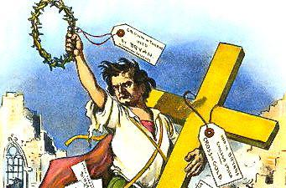
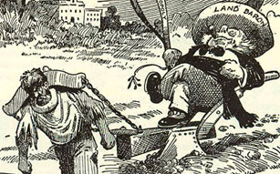
Bimetallism
Massacre
Debt peonage
Exoduster
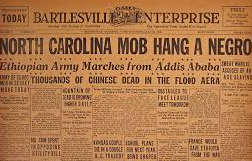
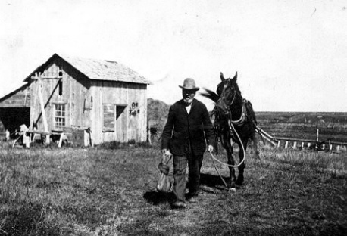
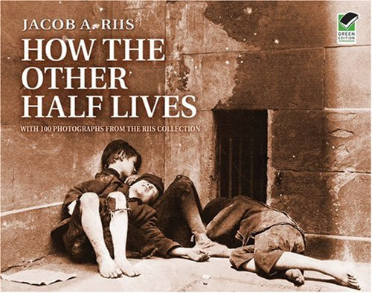
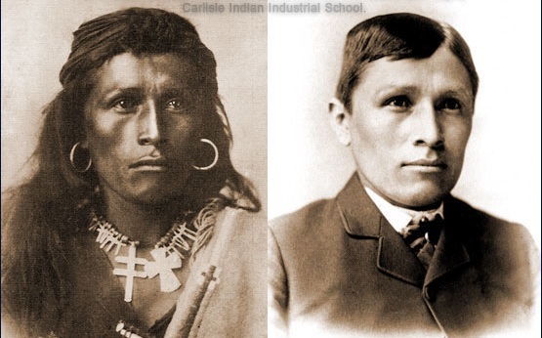
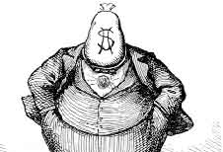
Lynching
Assimilation
Political machine
Muckraker
Homesteader

